Online Secure Student Information System
Secure Software Engineering Course Project Report
Prince Mohammad Bin Fahd University
College of Computer Engineering and Science
Spring 2025-2026
Item | Details
Course | Secure Software Engineering
Project | Secure Student Information System Website
Team | Tarik Fareed , Muneer ELmoussa
Repository | Public GitHub repository: add URL here after upload

Prepared deliverable: report, short presentation, and secure login implementation code.

1. Introduction

1.1 General Description
The Online Secure Student Information System (Secure SIS) is a web-based application for managing and viewing student grades. Students can create and update accounts, log in, and view grades. Instructors can post and update grades for courses assigned to them. Because the system stores sensitive academic and identity data, security must be included throughout the Software Development Life Cycle (SDLC), from requirements through design, implementation, testing, deployment, and maintenance.

1.2 Project Scope
- In scope: account creation, account update, login, grade viewing, grade posting, grade updating, role-based access control, secure database design, secure web design, threat modeling, risk assessment, secure login code, and security test planning.
- Out of scope: full implementation of every system function, mobile application development, payment processing, biometric authentication, and production cloud deployment automation.

1.3 Objectives
- Protect confidentiality, integrity, and availability of student and instructor data.
- Prevent common web attacks such as SQL injection, cross-site scripting, session hijacking, brute-force login attempts, and broken access control.
- Apply least privilege, defense in depth, secure defaults, complete mediation, input validation, and secure error handling.
- Provide secure login implementation code that validates inputs and uses parameterized database queries.

2. Security Requirements Analysis

2.1 Functional Requirements
ID | Requirement | Primary Actor
FR-1 | Create a student, instructor, or administrator account with approved information. | Admin / User
FR-2 | Update account information such as email, password, and profile details. | Authenticated User / Admin
FR-3 | Authenticate users through a secure login process. | All Users
FR-4 | Allow students to view only their own grades. | Student
FR-5 | Allow instructors to post grades for assigned courses only. | Instructor
FR-6 | Allow instructors to update grades for assigned courses only with audit logging. | Instructor

2.2 Non-Functional Requirements
Category | Requirement
Security | Authentication, authorization, encryption, audit logs, input validation, rate limiting, and secure session management must be enforced.
Privacy | Student grades and personal information must be visible only to authorized users.
Availability | The system should remain available during normal academic usage and handle expected login and grade viewing loads.
Usability | Security controls should not prevent normal students and instructors from completing authorized tasks.
Maintainability | The system should use modular components, secure coding standards, code review, and dependency management.
Compliance | Academic records should be handled according to university policy and applicable data protection expectations.

2.3 Security Requirements
ID | Security Requirement
SR-1 | Use strong password policy and store passwords only as salted, adaptive hashes.
SR-2 | Use parameterized SQL queries for all database access.
SR-3 | Enforce role-based access control: student, instructor, and administrator.
SR-4 | Use HTTPS/TLS in deployment and mark cookies Secure, HttpOnly, and SameSite.
SR-5 | Validate and normalize all user input on the server side.
SR-6 | Log authentication failures, grade changes, privilege changes, and suspicious activity.
SR-7 | Use CSRF protection for state-changing requests.
SR-8 | Use output encoding to prevent stored and reflected XSS.
SR-9 | Apply account lockout or throttling after repeated login failures.
SR-10 | Use secure error handling that does not reveal credentials, SQL errors, or stack traces.

2.4 Assets
Asset | Description | Security Goal
Student grade records | Course grades, GPA-related data, and grade history. | Confidentiality and integrity
User accounts | Student, instructor, and admin profiles. | Confidentiality and integrity
Credentials | Passwords and session identifiers. | Confidentiality
Course assignments | Instructor-to-course and student-to-course mappings. | Integrity
Audit logs | Security events and grade change history. | Integrity and availability
Application code | Login and system business logic. | Integrity
Database | Persistent storage for accounts, courses, and grades. | Confidentiality, integrity, availability

2.5 Threats
Threat ID | Threat | Targeted Asset | STRIDE Category
T1 | SQL injection through login or grade forms. | Database / credentials | Tampering, Information Disclosure
T2 | Brute-force password guessing. | User accounts | Spoofing
T3 | Broken access control allowing a student to view another student's grades. | Grade records | Elevation of Privilege, Information Disclosure
T4 | Instructor posts or updates grades for a course not assigned to them. | Grade records | Tampering, Elevation of Privilege
T5 | Session hijacking or fixation. | Session IDs | Spoofing
T6 | Stored XSS through account names or course fields. | Users / browser session | Tampering, Information Disclosure
T7 | CSRF attack changing account or grade data. | Accounts / grades | Tampering
T8 | Sensitive data leakage through logs or error messages. | Credentials / grades | Information Disclosure
T9 | Unauthorized database administrator action or stolen DB backup. | Database | Information Disclosure, Tampering
T10 | Denial-of-service against login or grade viewing. | Application availability | Denial of Service

2.6 Risk Assessment and Management
Risk score is calculated as Likelihood (1-5) x Impact (1-5). Management actions prioritize high-risk items first.
Threat | Likelihood | Impact | Score | Risk Level | Management Action
T1 SQL injection | 4 | 5 | 20 | High | Parameterized queries, validation, least-privilege DB user, security tests.
T2 Brute force | 4 | 4 | 16 | High | Rate limiting, lockout, MFA-ready design, monitoring.
T3 Broken access control | 3 | 5 | 15 | High | Server-side authorization checks on every request.
T4 Unauthorized grade update | 3 | 5 | 15 | High | Course ownership checks, audit logs, approvals if needed.
T5 Session hijacking | 3 | 4 | 12 | Medium | TLS, secure cookies, session rotation, idle timeout.
T6 XSS | 3 | 4 | 12 | Medium | Output encoding, Content Security Policy, validation.
T7 CSRF | 3 | 4 | 12 | Medium | CSRF tokens and SameSite cookies.
T8 Data leakage | 2 | 5 | 10 | Medium | Generic errors, log redaction, secure configuration.
T9 DB backup theft | 2 | 5 | 10 | Medium | Encryption at rest, access control, backup protection.
T10 DoS | 2 | 4 | 8 | Medium | Rate limiting, caching, monitoring, capacity planning.

2.7 Misuse Cases
Misuse Case | Attacker Goal | Security Control
MC-1: Login SQL injection | Bypass authentication using crafted username/password. | Prepared statements, input validation, generic errors.
MC-2: Student changes URL parameter | View another student's grade by changing student_id. | Ignore client-provided IDs and authorize by session identity.
MC-3: Instructor edits other course | Change grade for course not assigned to them. | Course-instructor mapping check and audit logging.
MC-4: Credential stuffing | Try leaked passwords against many accounts. | Rate limiting, monitoring, password policy, MFA-ready design.
MC-5: Stored XSS | Inject script in profile/course field. | Output encoding, CSP, input allowlists.
MC-6: CSRF grade change | Trick instructor into submitting hidden grade update. | CSRF tokens and SameSite cookies.

3. Securing Design

3.1 System Architecture and Components
Secure SIS uses a layered web architecture. The browser communicates with the web server over HTTPS. The application layer contains controllers, validation, authentication, authorization, business rules, and audit logging. The database layer stores normalized tables for users, roles, courses, enrollments, instructor assignments, grades, and audit logs. Administrative tasks are separated from student and instructor functions.
Component | Responsibility | Security Controls
Browser/UI | Login, account forms, grade pages. | CSRF token handling, secure forms, no sensitive data in client storage.
Web/Application Server | Routes, validation, authentication, authorization, business logic. | RBAC, input validation, secure sessions, generic errors.
Authentication Service | Login, password verification, session creation. | Password hashing, rate limiting, session rotation.
Authorization Layer | Verifies role and object ownership for each request. | Least privilege, complete mediation.
Database | Stores accounts, courses, grades, and logs. | Parameterized queries, encryption at rest, DB least privilege.
Audit Logger | Records security and grade-change events. | Tamper-resistant logs and redaction.

3.2 Threat Modeling Using Microsoft STRIDE Approach
The Microsoft threat modeling approach starts by defining the architecture, drawing the data flow diagram, identifying trust boundaries, enumerating threats with STRIDE, ranking risks, and selecting mitigations.
DFD Element | Trust Boundary | Main Threats | Mitigations
Browser to Web Server | Internet to application | Spoofing, tampering, session theft | HTTPS, HSTS, secure cookies, CSRF tokens.
Login Controller | Unauthenticated to authenticated area | SQL injection, brute force, enumeration | Prepared statements, throttling, generic errors.
Grade Controller | Authenticated user to protected resource | Broken access control, tampering | RBAC, object-level authorization, audit log.
Application to Database | Application to data store | Data leakage, SQL injection, DB misuse | Least-privilege DB account, encryption, prepared queries.
Admin Functions | Privileged boundary | Privilege misuse, repudiation | Strong authorization, approvals, audit logging.

STRIDE | Example in Secure SIS | Primary Mitigation
Spoofing | Attacker logs in as another student. | Strong password hashing, rate limiting, optional MFA, secure sessions.
Tampering | Instructor changes grade outside assigned course. | Server-side authorization and immutable audit history.
Repudiation | User denies changing a grade. | Timestamped audit logs with actor, IP, course, old value, and new value.
Information Disclosure | Student sees another student's grade. | Object-level access control and encrypted transport.
Denial of Service | Repeated login requests overload service. | Rate limiting, monitoring, caching, and scaling.
Elevation of Privilege | Student accesses instructor route. | Role checks, route guards, and secure defaults.

3.3 Security Design Principles Applied
- Least privilege: students can read only their grades, instructors can modify only assigned courses, and the application uses a restricted database account.
- Defense in depth: input validation, parameterized queries, RBAC, secure sessions, audit logs, and monitoring all work together.
- Complete mediation: every request checks authentication, role, and ownership on the server side.
- Secure defaults: new accounts have the minimum role and no grade-editing permission unless assigned.
- Fail securely: errors return generic messages and do not expose SQL details, stack traces, or account existence.
- Economy of mechanism: authentication, authorization, and logging are centralized services, reducing duplicated security code.
- Separation of duties: administrators manage accounts, instructors manage course grades, and students only view their own records.

3.4 Database Security and Encryption
- Passwords are stored using salted adaptive hashing such as bcrypt, Argon2, or Werkzeug PBKDF2/scrypt configuration. Plaintext passwords are never stored.
- Grade and user queries are parameterized and never constructed by concatenating user input.
- The database user used by the web application has only required SELECT/INSERT/UPDATE permissions and no administrative privileges.
- TLS protects data in transit. Database backups and production storage should use encryption at rest.
- Audit logs record grade changes with actor, timestamp, affected record, old grade, new grade, and source IP.

4. Secure Implementation

4.1 Secure Coding Guidelines
- Validate all input on the server using allowlists, length limits, and normalization.
- Use prepared statements or ORM parameter binding for all SQL operations.
- Hash passwords with a modern adaptive algorithm and unique salt.
- Never reveal whether username or password was wrong; use a generic login failure message.
- Regenerate sessions after successful login and configure cookies as Secure, HttpOnly, and SameSite.
- Apply rate limiting to login attempts by account and source IP.
- Log suspicious events, but never log plaintext passwords or session IDs.
- Keep dependencies updated and perform code review and static analysis before deployment.

4.2 Defensive Login Process
The included implementation code demonstrates a secure login route using server-side input validation, CSRF checking, rate limiting, password hashing, secure session configuration, and parameterized SQL queries. A malicious username such as admin' OR ‘1’=‘1 is treated as data, not executable SQL, because the query uses placeholders.
Security Issue | Defensive Technique in Login Code
SQL injection | Uses parameterized query: SELECT ... WHERE email = ?
Password theft | Stores only salted password hashes and verifies with hash function.
Brute force | Uses simple per-IP and per-account throttling.
Session fixation | Clears old session and creates a new authenticated session.
CSRF | Checks CSRF token on POST login form.
Information leakage | Returns the same generic error for invalid email or password.

5. Secure Testing

5.1 Security Test Case for Each Identified Threat
Threat | Security Test Case | Expected Result
T1 SQL injection | Submit username: admin@example.com' OR '1'='1 and any password. | Login fails; query is not altered; no SQL error is exposed.
T2 Brute force | Submit six wrong passwords for one account from one IP. | Requests are throttled or temporarily locked.
T3 Broken access control | Student A requests /grades?student_id=StudentB. | Request is denied or returns only Student A data.
T4 Unauthorized grade update | Instructor attempts to update grade for a course not assigned. | Update is rejected and logged.
T5 Session hijacking/fixation | Reuse session ID before and after login. | Session ID changes after login; insecure cookies are not accepted.
T6 Stored XSS | Enter <script>alert(1)</script> in profile or course field. | Script is encoded and not executed.
T7 CSRF | Submit grade update without valid CSRF token. | Request is rejected with 403.
T8 Data leakage | Force server error during login. | Generic error displayed; no stack trace or SQL details.
T9 DB backup theft | Attempt to read backup without authorization. | Access denied; backup is encrypted.
T10 DoS | Send high-volume repeated login requests. | Rate limiting and monitoring activate; service remains responsive.

5.2 Two Security Test Cases for Each Function
Function | Test Case 1 | Test Case 2
Create account | Try duplicate email and verify no account takeover or data overwrite. | Submit malicious script in name field and verify output encoding.
Update account | Try updating another user's account ID and verify denial. | Submit weak password and verify policy rejection.
Login | Try SQL injection payload and verify login fails safely. | Try repeated wrong passwords and verify throttling.
View grades | Student requests another student's grades and is denied. | Unauthenticated user requests grade page and is redirected to login.
Post grades | Student attempts instructor-only endpoint and is denied. | Instructor posts grade for unassigned course and is denied.
Update grades | Instructor changes grade and audit log records old/new value. | Submit invalid grade value outside allowed range and verify rejection.

5.3 Security Acceptance Criteria
- All high-risk threats have implemented mitigations and passing security tests.
- All authentication and grade-management routes enforce server-side authorization.
- No SQL injection payload changes database query logic.
- All grade changes are audit logged.
- No sensitive information appears in error messages, logs, or client-side storage.

6. Conclusion
The Secure SIS design applies security throughout the SDLC. It identifies sensitive assets, evaluates threats, manages risk, and uses a secure architecture based on least privilege, defense in depth, complete mediation, secure database access, encryption, and strong auditing. The included login implementation demonstrates practical defensive coding against input validation failures and SQL injection, while the security test plan verifies the most important controls before release.

References
- OWASP Web Security Testing Guide and OWASP Top 10 concepts for web application risks.
- Microsoft STRIDE threat modeling approach for identifying spoofing, tampering, repudiation, information disclosure, denial of service, and elevation of privilege threats.
- Course project brief: Secure Software Engineering, Prince Mohammad Bin Fahd University, Spring 2025-2026.

Threat Model Diagram and Table
System: Online Secure Student Information System (SIS) for student grade management. The system supports account creation, account update, login, viewing grades, posting grades, and updating grades.

Threat Model Diagram (Microsoft STRIDE Approach)
The diagram shows external users, application components, databases, trust boundaries, and the main data flows where security threats may occur.
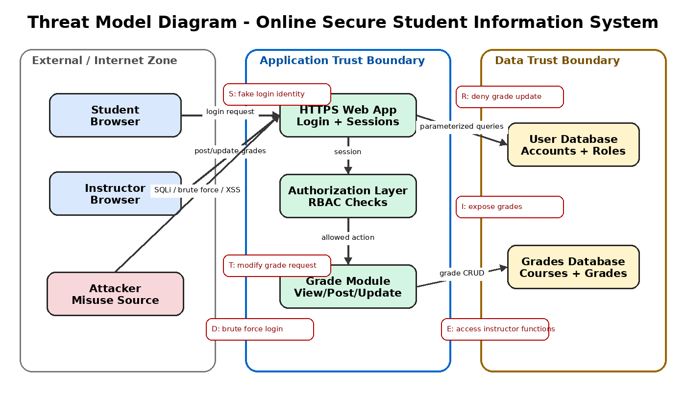
Figure 1. Threat model diagram with trust boundaries and STRIDE threat points.

Threat Model Table
STRIDE Category | Threat | Asset Affected | Impact | Mitigation / Security Control | Risk Level
Spoofing | An attacker attempts to log in using stolen or guessed credentials. | Student/instructor accounts | Unauthorized access to private grades and account data. | Use strong password policy, password hashing, account lockout, MFA if possible, and secure session handling. | High
Tampering | An attacker modifies grade values or request parameters before they reach the server. | Grades database | Incorrect grades and loss of academic integrity. | Enforce server-side authorization checks, validate all input, use parameterized queries, and log grade changes. | High
Repudiation | An instructor or attacker denies posting or changing a grade. | Audit logs and grade records | No accountability for sensitive grade changes. | Maintain tamper-resistant audit logs with user ID, timestamp, IP address, and action details. | Medium
Information Disclosure | A student accesses another student’s grades or sensitive account information. | Grades and personal data | Privacy breach and violation of confidentiality. | Apply role-based access control, encrypt data in transit with HTTPS, restrict database queries by user ID, and avoid verbose error messages. | High
Denial of Service | Repeated login attempts or automated requests overload the system. | Web application and authentication service | Legitimate users cannot access the system. | Use rate limiting, CAPTCHA after failed attempts, account lockout, monitoring, and secure server configuration. | Medium
Elevation of Privilege | A student accesses instructor-only functions such as posting or updating grades. | Grade management module | Unauthorized grade manipulation. | Apply least privilege, RBAC, server-side permission checks, secure session tokens, and separate student/instructor roles. | High
SQL Injection | Malicious input is entered in login or grade forms to manipulate database queries. | User database and grades database | Data theft, authentication bypass, or data modification. | Use prepared statements, input validation, least-privilege database accounts, and generic error messages. | High
Cross-Site Scripting (XSS) | Attacker injects malicious script into account or grade-related fields. | User sessions and web pages | Session theft or malicious actions on behalf of users. | Use output encoding, input validation, Content Security Policy, and secure cookie flags. | Medium
This threat model supports the project requirement to provide complete threat modeling using Microsoft’s approach and to identify threats, assets, risks, and security controls.

